**Project Design Phase-II**

**Technology Stack (Architecture & Stack)**

|  |  |
| --- | --- |
| Date | 15 October 2022 |
| Team ID | PNT2022TMID23612 |
| Project Name | Project - A Novel Method for Handwritten Digit Recognition. |
| Maximum Marks | 4 Marks |

**Technical Architecture:**

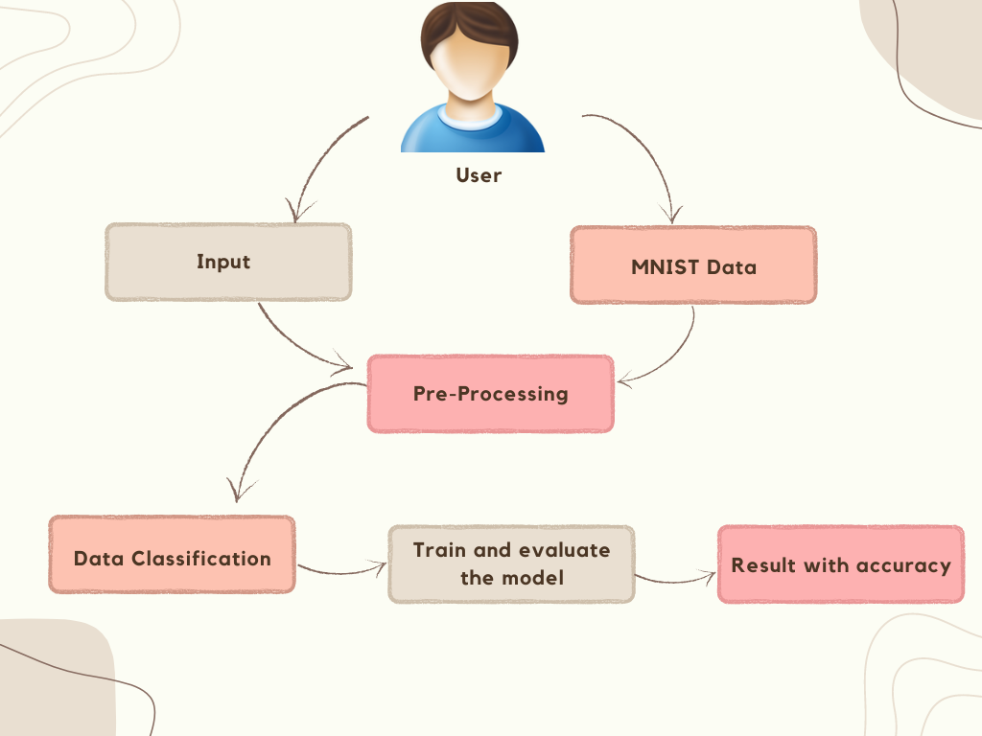

**Table-1 : Components & Technologies:**

|  |  |  |  |
| --- | --- | --- | --- |
| **S.No** | **Component** | **Description** | **Technology** |
|  | User Interface | Allows the user to enter the input and recognise the input using GUI. | HTML,CSS, JavaScript |
|  | Digit Prediction | Here the digit given as a input is predicted. | Keras,CNN. |
|  | Representation | Skeleton, counters, pixels or others. | Java / Python |
|  | Segmentation | Task of clustering parts of an image together that belong to the same object class. | Convolutional neural networks  & super pixels. |
|  | Machine Learning Model | Purpose of Machine Learning Model is to train and test the data and predict the user input. | Classification. |
|  | Infrastructure | Application deployment on local system Local server Configuration: Intel core i5/i3 10th Generation. | HTML, CSS |
|  | Neural Network | Automatically infer rules for recognizing handwritten digits | Convolutional neural network. |

**Table-2: Application Characteristics:**

| **S.No** | **Characteristics** | **Description** | **Technology** |
| --- | --- | --- | --- |
|  | Pre-processing | Data pre-processing is a process of preparing the raw data and making it suitable for a machine learning model. | Real time online handwritten character recognition system, based on an ensemble of  neural networks. |
|  | Open Source Frameworks | Enables developers to develop complex code and web application quickly. | Open source-Jupyter, anaconda navigator, flask framework. |
|  | Dataset | It Contains 60,000 training images. | MNIST |
|  | Security Implementation | After predicting the data, we don’t store any data so we can’t manipulate it in future. | Encryption |
|  | Performance | Neural networks achieve an accuracy of ~(98–99) percent in correctly classifying the handwritten digits. | Convolutional Neural Networks. |